Anthony Macchiaroli
Owner of 85 Cook Road Cornwall
P.O. Box 613
Bantam CT 06750

Perley H. Grimes, Jr, Cramer & Anderson Attorney representing the Town of Cornwall September 1, 2021
pgrimes@cramer-anderson.com
Dear Mr. Grimes

False Police Report from Town of Conwell Officials
It seems your client Town Of Cornwall has been giving false and misleading information to Law enforcement. I am pretty sure this is a crime but I am not an attorney, all I can do is file a civil suit.
: CT Gen Stat § 53a-180c (2013)
(a) A person is guilty of falsely reporting an incident in the second degree when, knowing the information reported, conveyed or circulated to be false or baseless, such person gratuitously reports to a law enforcement officer or agency (1) the alleged occurrence of an offense or incident which did not in fact occur, (2) an allegedly impending occurrence of an offense or incident which in fact is not about to occur, or (3) false information relating to an actual offense or incident or to the alleged implication of some person therein.
(b) Falsely reporting an incident in the second degree is a class A misdemeanor.
Punishable by 1 year in prison and $2000 fine.

Police Report
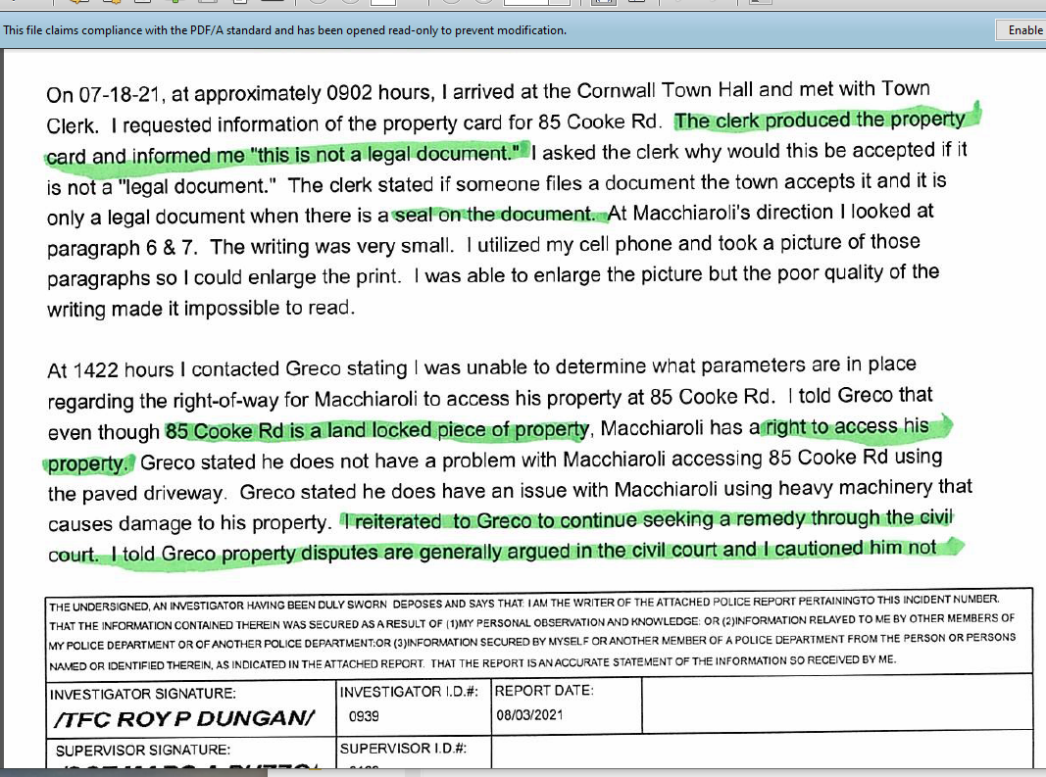
It seems the town clerk informed law enforcement that the property card for 85 Cook road was not a legal document. This to me infers a crime was committed.
Even worse after the fact the field card was altered by the Assessor, Questioning the legality of the transfer and ownership of the property.
Even worse than that Karen town employee has been canvasing the neighbors telling them not to get involved with the dispute over ownership of the property.
This is the third time I have sent you correspondence on the property and you haven’t gotten back to me.
I left you a voice message that you haven’t returned
I have left the Assessor a voice message that she hasn’t returned.
I would like to know who altered the field card, on whose authority, the date it was altered, and why I wasn’t notified.
As usual Thanks
Tony 860 459-0915
CC
Vera cwltownclerk@optonline.net
Karen cwlanduse@optonline.net
Gordon cwlselectmen@optonline.net
Assesor
JoAnn Dodge
Barbara Bigos
cwlassessor@optonline.net

