August 5, 2025

VIA E-MAIL

Mr. David V. DeRosa
Attorney at Law
42 Terrace Avenue
P.O. Box 992
Naugatuck, CT 06770

Re: Sources & Documents
85 Cook Road, Cornwall, CT

REMA Job No.: 25-2831-RDG11

Dear Attorney DeRosa:

At your request, the undersigned principal of Rema Ecological Services, LLC (REMA), is providing herein a list of the sources and documents utilized to generate an affidavit, dated September 9th, 2023, in the matter of Anthony Macchiaroli v. Dave Greco, et. al. These supplement my observations during the January 17th, 2023 site visit along the route taken to Mr. Maccharoli’s property at the above-referenced address.

- 113 Photos taken during the January 17th, 2023 Site Visit.

- 9 Screenshots of the route taken on the January 17th, 2023 Site Visit, generated on a US Topo Maps application on an android phone, belonging to the undersigned.

- A Soil Map - State of Connecticut, by the USDA Natural Resources Conservation Service, showing the soil types mapped along the route taken during the January 17th, 2023 Site Visit.

- A figure generated through the National Geologic Map Database showing the topography along the route taken during the January 17th, 2023 Site Visit.

- A figure generated through Google Earth on an April 19, 2016 aerial photo, showing the building at 85 Cook Road, Cornwall, CT, and annotated with the route of the route taken during the January 17th, 2023 Site Visit.

Please feel free to contact us if you have any questions.

Respectfully submitted,

Rema Ecological Services, LLC
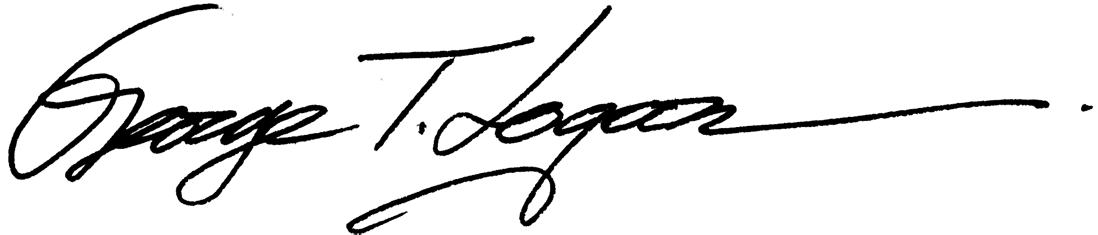

George T. Logan, MS, PWS, CSE
Principal Environmental Scientist

